**Real Time Mapping Of Epidemic Spread**

**ABSTRACT:**

This integrated healthcare platform offers a robust system for doctors and patients. Doctors can efficiently manage appointments, accepting or rejecting them, and input epidemic-related data. Patients can register, book appointments, track their status, and update their recovery status. The dashboard provides a comprehensive overview of epidemic disease details, allowing day and month-wise filtering. Users can download patient details and access graphical representations of epidemic cases and recovery rates for informed decision-making. This streamlined approach combines mathematical modeling and machine learning with practical healthcare management, fostering a proactive and data-driven response to epidemics.

**Keywords:** Healthcare Modules, Admin, Doctor epidemic disease.

**STATEMENT ABOUT THE PROBLEM**

The current healthcare decision-making landscape faces challenges in effectively responding to epidemics, such as COVID-19. Existing studies lack generalization or surveillance data, leading to suboptimal policy decisions. City administrators rely on open-loop, belief-based decision-making, hindering timely policy enforcement. To address these issues, there's a need for an integrated healthcare platform. The proposed platform aims to merge mathematical modeling and machine learning for accurate epidemic predictions, providing doctors with tools for efficient appointment management and real-time epidemic data input. Patients can seamlessly navigate the system, booking appointments and monitoring their recovery status. The overarching problem is the lack of a comprehensive, data-driven approach to epidemic control and patient care.

**SCOPE:**

The scope of this integrated healthcare platform encompasses the efficient management of epidemic scenarios, merging mathematical modeling, machine learning, and practical healthcare functionalities. The platform facilitates doctors in optimizing appointment schedules and entering epidemic-related data, ensuring timely and data-driven decision-making. Patients can seamlessly register, book appointments, and monitor their recovery progress. The comprehensive dashboard extends the scope to include detailed day and month-wise epidemic insights, downloadable patient data, and graphical representations for informed analysis. This system's overarching scope is to enhance pandemic response, offering a holistic approach that amalgamates technological advancements with real-world healthcare management.

**OBJECTIVE OF THE PROJECT:**

The objective is to create an integrated healthcare platform that optimizes pandemic response. Incorporating mathematical modeling and machine learning, the system empowers doctors to efficiently manage appointments and input epidemic-related data. Patients can easily register, book appointments, track statuses, and update their recovery status. The dashboard offers a comprehensive view of epidemic details with day and month-wise filtering, accompanied by downloadable patient information and graphical representations for informed decision-making. This platform aims to streamline healthcare management, fostering a proactive, data-driven approach to epidemic control and patient care.

**EXISTING METHOD**

The existing healthcare system lacks a cohesive approach to epidemic management. Decision-making relies on outdated models and lacks real-time data integration. Doctor-patient interactions are fragmented, hindering efficient appointment scheduling and epidemic data collection. The absence of a centralized platform results in delayed responses to emerging health crises, undermining the effectiveness of healthcare policies. An integrated solution is imperative to address these shortcomings and enhance the overall resilience of the healthcare system.

**DISADVANTAGES**

While the proposed integrated healthcare platform brings several advantages, potential disadvantages include:

**1. Technological Barriers:** Users with limited technological proficiency may face challenges navigating and utilizing the platform effectively.

**2. Data Security Concerns:** The integration of sensitive health data requires robust security measures to safeguard patient information from potential breaches.

**3. Implementation Costs:** Developing and implementing the platform may involve significant initial costs for technology integration, training, and system deployment.

**4. Resistance to Change:** Healthcare professionals and institutions may resist adopting new technologies, leading to a slow acceptance and integration process.

**5. Dependency on Data Accuracy:** The success of the platform heavily relies on the accuracy and reliability of input data, making it vulnerable to errors or misinformation.

**6. Privacy Issues:** Patient privacy concerns may arise, especially with the collection and storage of personal health information, necessitating strict compliance with privacy regulations.

**7. Limited Accessibility:** Accessibility challenges for patients without reliable internet access or in remote areas may limit the inclusivity of the platform.

**8. Maintenance and Upkeep:** Continuous maintenance and updates are crucial to ensure the platform's effectiveness and adaptability to evolving healthcare needs.

**PROPOSED SYSTEM:**

The proposed healthcare system integrates mathematical modeling, machine learning, and practical functionalities to revolutionize epidemic response. Offering doctors tools for streamlined appointment management and real-time epidemic data input, the platform ensures efficient decision-making. Patients can easily navigate, book appointments, and monitor their recovery. The comprehensive dashboard provides detailed epidemic insights. This holistic approach aims to bridge existing gaps, enabling a proactive and data-driven healthcare system, optimizing epidemic control, and improving patient care.

**PROJECT FLOW:**

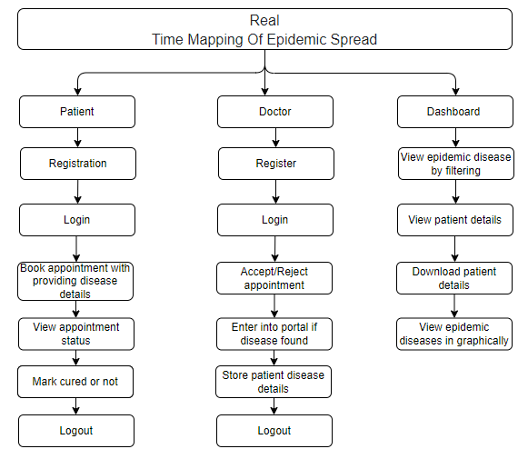

**ADVANTAGES:**

The proposed integrated healthcare platform presents several advantages:

**1. Data-Driven Decision Making:** Utilizes mathematical modeling and machine learning for accurate epidemic predictions, enabling informed and timely decision-making.

**2. Efficient Appointment Management:** Streamlines the process for doctors, allowing them to accept or reject appointments seamlessly, improving overall scheduling efficiency.

**3. Real-Time Epidemic Data Input:** Facilitates immediate and accurate recording of epidemic-related information, enhancing the system's responsiveness to emerging health crises.

**4. Patient Empowerment:** Patients benefit from easy appointment booking, status tracking, and the ability to update their recovery status, promoting active involvement in their healthcare journey.

**5. Comprehensive Dashboard:** Provides a centralized view of epidemic details with filtering options, downloadable patient data, and graphical representations, enhancing overall situational awareness.

**6. Proactive Epidemic Control:** The platform's holistic approach enables proactive measures in epidemic control, contributing to a more resilient and adaptive healthcare system.

**7. Optimized Healthcare Policies:** Offers insights for policymakers with threshold mechanisms, aiding in the formulation of targeted and effective healthcare policies based on real-time data and predictions.

**Architecture:**

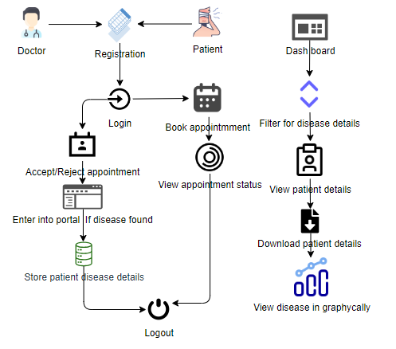

**SOFTWARE FRONT END REQUIREMENTS**

# **H/W CONFIGURATION:**

# Processor - I3/Intel Processor

Hard Disk - 160GB

Key Board - Standard Windows Keyboard

Mouse - Two or Three Button Mouse

Monitor - SVGA

RAM - 8GB

**S/W CONFIGURATION:**

* Operating System : Windows 7/8/10
* Server side Script : HTML, CSS, Bootstrap & JS
* Programming Language : Python
* Libraries : Flask, Pandas, Mysql.connector, Os, Smtplib, Numpy
* IDE/Workbench : PyCharm
* Technology : Python 3.6+
* Server Deployment : Xampp Server

**MODULES/IMPLEMENTATION**

**1. Doctor:**

**Register:** The doctor can register with the details like name, email, password, conform password, Contact number, and address

**Login:** After registration they will login with email and password

**View appointments:** Doctors can view all Symptoms which is given by the patients and based on the symptoms he can enter the data like patient is having the Epidemic Spread.

**Add epidemic disease:** Once the doctor can view the symptoms he has to add like patient is having the epidemic disease.

**Recovered status:** Once the patient is mention like he has quire for the epidemic disease doctor can view that status.

**Logout**: After completion of the operation they can logout from the website.

**2. Patients:**

**Register:** The patients can register with the details like name, email, password, conform password, Contact number, and address

**Login:** After registration they will login with email and password

**Book appointment** Patients can add the symptoms like they are suffering.

**View appointment status** Patients can view the status of their request and they can check whether there are having the epidemic disease or not.

**Mark recovery:**  The patients can mark or update like they have queried or not form epidemic disease.

**Logout**: After completion of the operation they can logout from the website.

**Dashboard:** Here we can view that like how many people are suffering from the disease it will show in graphical manner.